**Install MAVEN**

**Pre-requisite: JDK**

* 1. Make sure JDK is installed, and JAVA_HOME environment variable is configured.
  2. Download the Maven zip file from : [Link](http://maven.apache.org/download.cgi)

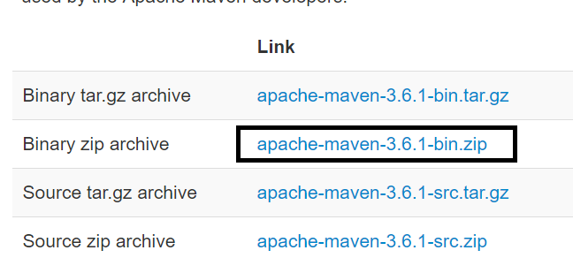

* 1. Unzip it to a folder.

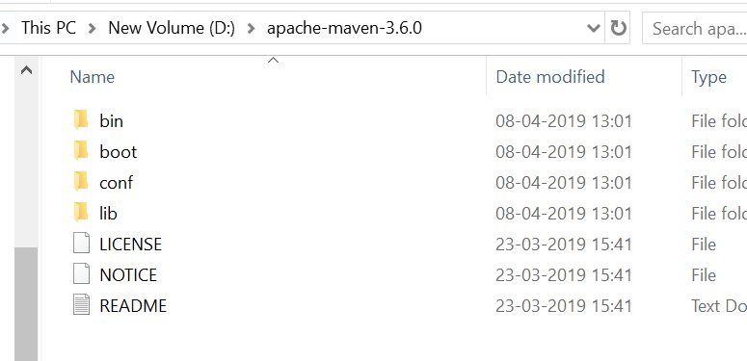

* 1. Add MAVEN_HOME in system variables

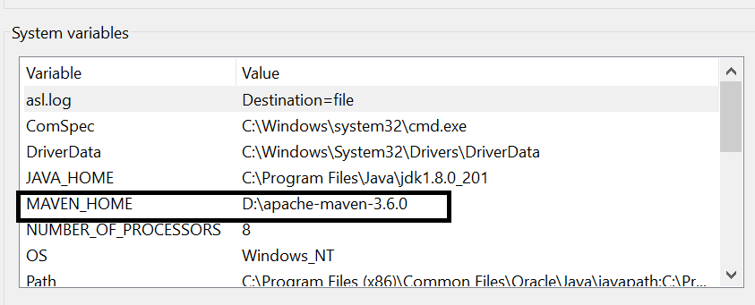

* 1. Add %MAVEN_HOME%\bin to PATH

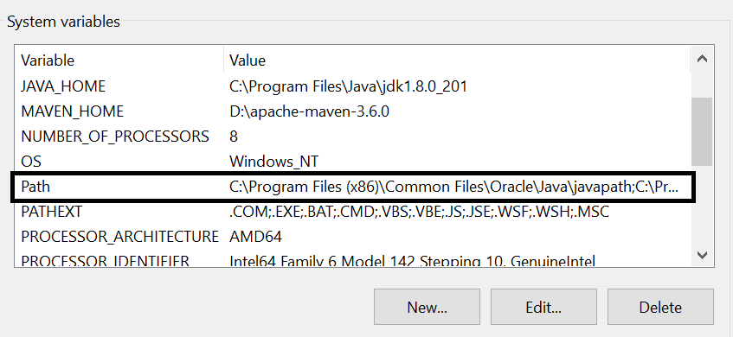 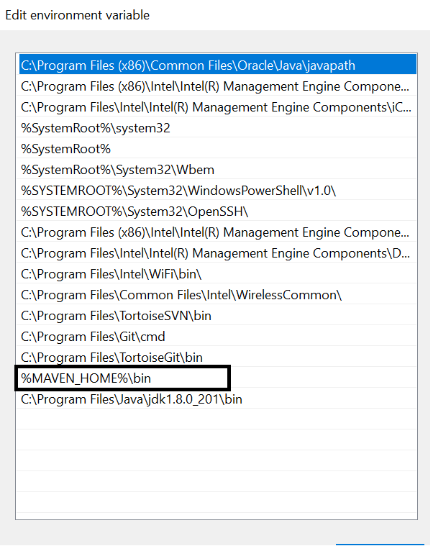

* 1. Verify MAVEN installation.

Open Command Prompt -> Type command

> mvn –version

